|  |
| --- |
| VMware vSphere Hypervisor (ESXi ISO) image |
| Boot your server with this image in order to install or upgrade to ESXi (ESXi requires 64-bit capable servers). This ESXi image includes VMware Tools. |

|  |
| --- |
| VMware vSphere Hypervisor (ESXi) Offline Bundle |
| Contains VIB packages and image profiles for ESXi including VMware Tools. Use the image profiles and the VIB packages with VMware Image Builder and VMware Auto Deploy to create custom image/ISO generation for ESXi deployments. |

Offlline Bundle for updating ESXi is like patch

For VCenter 3 ta file darim

1. Yeki baraye install VCSA hast ke ISO format hast

**VMware vCenter Server Appliance**

**Link:** [VMware-VCSA-all-7.0.0-16189094.iso](https://fdn.digiboy.ir/dlir-s3/VMware-VCSA-all-7.0.0-16189094.iso)

We can mount this ISO file in

1. File dovom zip ast :

**VMware vCenter Server Appliance Update Bundle**

**Link:** [VMware-vCenter-Server-Appliance-7.0.0.10300-16189094-updaterepo.zip](https://fdn.digiboy.ir/dlir-s3/VMware-vCenter-Server-Appliance-7.0.0.10300-16189094-updaterepo.zip)

Patch VMware vCenter Server Appliance (VCSA) from Offline Depot ZIP file:

File bayad unzip konim badesh be ye webserver and make sure we can access with url

Maslana address ma hastesh : rootctl.zapto.org dar root in webserver yr folder be name vcsa

dorost mikonim va hameye file zip dar on copy mikonim ke mammoolan dota folder dareh

(manifest and package-pool)

Badesh be “vCenter Server Appliance Management” log in mikonim <https://vcsa_ip_address:5480>

Badesh be update and setting raftteh va badesh be “ Use Specified repository “

Badesh oon folder peyda kardeh rootctl.zapto.org /vcsa then we go press the ok

Badesh bayad 🡪 Install Updates ro clcick kard

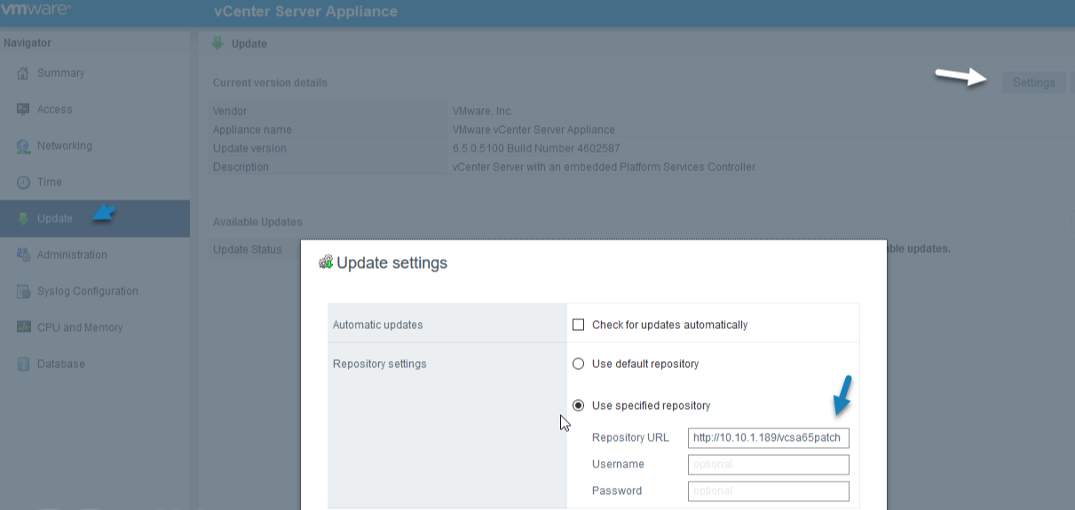

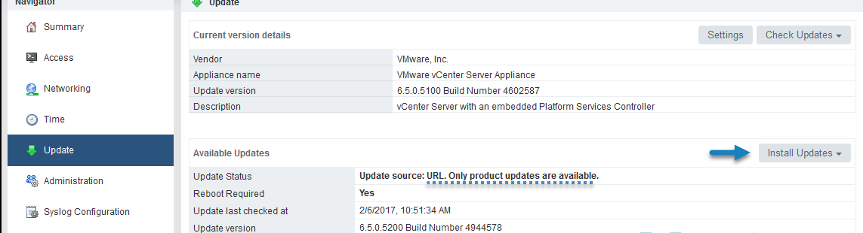

1. File sevom Full Patch or PF

**Patch for VMware vCenter Server Appliance**

**Link:** [VMware-vCenter-Server-Appliance-7.0.0.10300-16189094-patch-FP.iso](https://fdn.digiboy.ir/dlir-s3/VMware-vCenter-Server-Appliance-7.0.0.10300-16189094-patch-FP.iso)

Upload the file to a datastore visible by an ESXi host that runs the VCSA.

connect to your vSphere web client (or you can do it also from ESXi host client if you want to) and go to Edit Settings > CD/DVD drive and select Datastore ISO.

In file ISO ro mount konid like CD/DVD

connect to your VCA VAMI user interface via https://ip_of_vcsa:5480

Badesh ba root be VCSA vared shaved

Then go to Update > Check CD ROM. You should see the available updates which are now mounted via CD ROM of the VM.

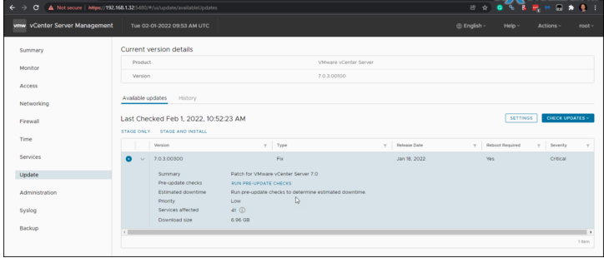

create a Snapshot or backup in any other way your VCSA

proceed with the upgrade. Accept the EULA and click Next.

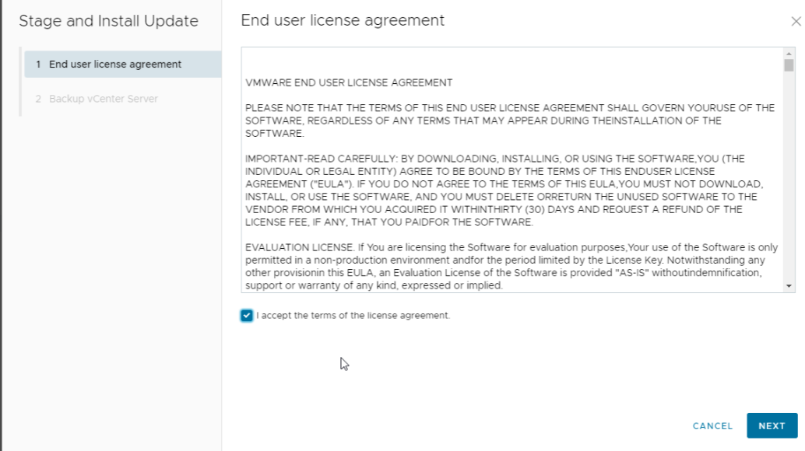

Click finish while checking the “I have backed up vCenter Server and its associated databases”. (You see?)

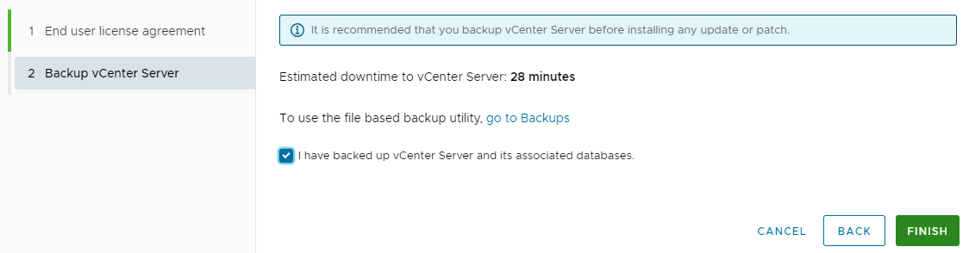

Note:

You can also do the patching via CLI when connection to the VCSA.

Log in to the appliance shell

To stage the ISO:

*software-packages stage –iso*

To see the staged content:

*software-packages list –staged*

To install the staged rpms:

*software-packages install –staged*

***Update ESXi 6.5 using an Offline Bundle:***

**Upload the update xxx.zip file to a datastore accessible by the host.**

**Place the host into Maintenance Mode.**

**Type the following command:**

esxcli software vib update -d /vmfs/volumes/<DATASTORE-UUID>/update-from-esxi6.5-xxx.zip

**Patching a Standalone ESXi Host**

**esxcli Method**

Upload the downloaded Zip to a datastore the host can access.

SSH into the host. First thing to so is ensure all VM’s are powered down.

Then put the host in maintenance mode:

esxcli system maintenanceMode set --enable true

We also need the –depot switch to tell the command we are installing a packaged update. In this example:

esxcli software vib update --depot /vmfs/volumes/LocalHDD/ESXi650-201801001.zip

**PowerCLI Method**

There is a key difference when using PowerCLI in that you need to extract the Zip file before it’s uploaded to the datastore. So extract the Zip file to a datastore the Host can access.

Now we need to connect to the Host in PowerCLI:

PS C:\Users\cwe> Connect-VIServer -Server esxi-host -User root -Password Password1

Now we use need to enter maintenance mode:

PS C:\Users\cwe> Set-VMHost -State Maintenance

Now we can use the PowerCLI command [Install-VMHostPatch](https://www.vmware.com/support/developer/windowstoolkit/wintk40u1/html/Install-VMHostPatch.html). The only needs one argument supplied -HostPath. This is the location of the extracted Zip file:

PS C:\Users\cwe> Install-VMHostPatch -HostPath /vmfs/volumes/LocalHDD/ESXi650-201801001/metadata.zip

We have to reboot the Host:

PS C:\Users\cwestwater> Restart-VMHost -Confirm

**Manually Patching an ESXi Host from the CLI**

[VMware Patch Tool](https://my.vmware.com/group/vmware/patch#search)

downloaded **ESXi670-201901001.zip**

This ZIP file – and all ESXi patches – are what is referred to as an “offline bundle”. Offline bundles are collections of VIBs bundled with metadata describing their contents. You don’t need to extract the ZIP file as part of the upgrade process. The ESXi host will process the ZIP file automatically to pull out the modules and metadata.

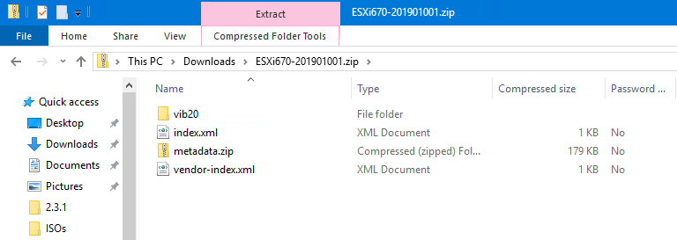

In the ZIP file, the VIBs are contained in the vib20 directory. The other files contain metadata, including vendor related information.

The first thing we’ll need to do is upload the file over to a location that can be accessed by the ESXi hosts. Quite often, WinSCP is used for this process, but you can also use the datastore browser to put it in a shared datastore that can be accessed by all your hosts.

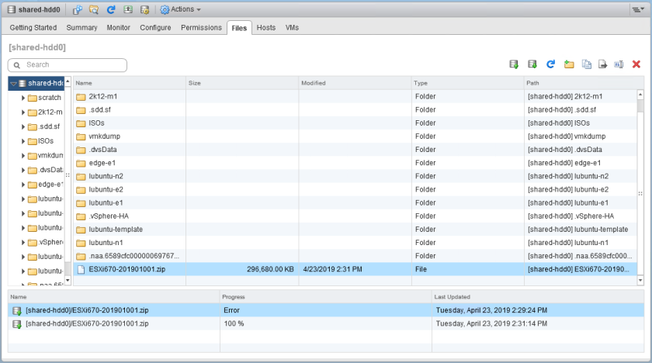

I uploaded it to the root of the datastore called shared-hdd0. Before you begin, it would be a good idea to put the host into Maintenance Mode.

I then opened an SSH session and logged into esx-e1 as root:

[root@esx-e1:~] ls /vmfs/volumes/shared-hdd0/*.zip

/vmfs/volumes/shared-hdd0/ESXi670-201901001.zip

Make a note of the full path. Notice that the datastore name is used after **/vmfs/volumes**.

The command to initiate the update is **esxcli software vib update**, specifying an offline depot using the **-d** or **–depot** flags. The syntax I used is listed below:

[root@esx-e1:~] esxcli software vib update --depot=/vmfs/volumes/shared-hdd0/ESXi670-201901001.zip

My first attempt actually failed with the following error:

 [StatelessError]

 The transaction is not supported: VIB VMware_bootbank_lsu-lsi-lsi-msgpt3-plugin_1.0.0-9vmw.670.1.39.11675023 cannot be live installed. VIB VMware_bootbank_esx-base_6.7.0-1.39.11675023 cannot be live installed. VIB VMware_bootbank_esx-update_6.7.0-1.39.11675023 cannot be live installed. VIB VMware_bootbank_vsan_6.7.0-1.39.11399593 cannot be live installed. VIB VMware_bootbank_lsu-lsi-lsi-msgpt3-plugin_1.0.0-8vmw.670.0.0.8169922 cannot be removed live. VIB VMware_bootbank_esx-update_6.7.0-1.28.10302608 cannot be removed live. VIB VMware_bootbank_esx-base_6.7.0-1.28.10302608 cannot be removed live. VIB VMware_bootbank_vsan_6.7.0-1.28.10290435 cannot be removed live.

Please refer to the log file for more details.

This is a common issue where certain kernel modules fail to unload. If you run into this, the workaround is quite simple. Make sure the host is in maintenance mode, reboot it and then run the command again. In my case it was successful after doing this:

[root@esx-e1:~] esxcli software vib update --depot=/vmfs/volumes/shared-hdd0/ESXi670-201901001.zip

Installation Result

   Message: The update completed successfully, but the system needs to be rebooted for the changes to be effective.

**Reboot Required: true**

   VIBs Installed: VMware_bootbank_esx-base_6.7.0-1.39.11675023, VMware_bootbank_esx-update_6.7.0-1.39.11675023, VMware_bootbank_lsu-lsi-lsi-msgpt3-plugin_1.0.0-9vmw.670.1.39.11675023, VMware_bootbank_vsan_6.7.0-1.39.11399593, VMware_bootbank_vsanhealth_6.7.0-1.39.11399595

   VIBs Removed: VMware_bootbank_esx-base_6.7.0-1.28.10302608, VMware_bootbank_esx-update_6.7.0-1.28.10302608, VMware_bootbank_lsu-lsi-lsi-msgpt3-plugin_1.0.0-8vmw.670.0.0.8169922, VMware_bootbank_vsan_6.7.0-1.28.10290435, VMware_bootbank_vsanhealth_6.7.0-1.28.10290721

   VIBs Skipped: VMW_bootbank_ata-libata-92_3.00.9.2-16vmw.670.0.0.8169922,

<snip>

Once the update is finished, it’ll be necessary to reboot the host.

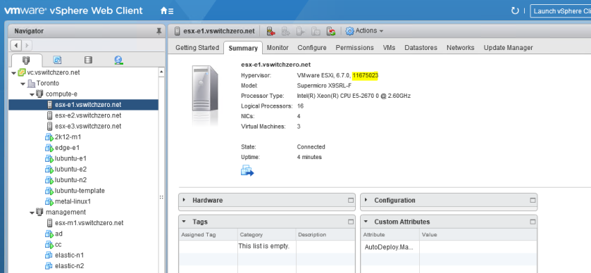

That’s it! Not difficult at all, and can be useful for standalone ESXi hosts that don’t have access to vCenter and Update Manager.

How to Patch Free VMware ESXi Standalone Host

Upload the patch you just downloaded to a datastore visible to your ESXi host (local or shared datastore).

Type this command for update:

*esxcli software vib update -d /vmfs/volumes/<your_datastore>/update-from-esxi5.5-5.5_update02-2068190.zip*