VMware Paravirtual SCSI Controllers:

VMware Paravirtual SCSI controllers are high performance storage controllers that can result in greater throughput and lower CPU use. These controllers are best suited for high performance storage environments.

VMware Paravirtual SCSI controllers are available for virtual machines with ESXi 4.x and later compatibility. Disks on such controllers might not experience optimal performance gains if they have snapshots or if memory on the ESXi host is over committed. This behavior does not mitigate the overall performance gain of using VMware Paravirtual SCSI controllers as compared to other SCSI controller options.

**VMware Paravirtual SCSI Controller**[**ℑ**](https://eis.utoronto.ca/~vss/vsscli/examples/pvscsi.html#vmware-paravirtual-scsi-controller)

According to VMware, there are two main reasons to deploy a virtual machine with the Paravirtual SCSI controller:

PVSCSI adapters are high-performance storage adapters that can result in **greater throughput and lower CPU utilization**. PVSCSI adapters are best for environments, especially SAN environments, where hardware or applications drive a very high amount of I/O throughput. The VMware PVSCSI adapter driver is also compatible with the Windows Storport storage driver. PVSCSI adapters are not suitable for DAS environments. VMware Paravirtual SCSI adapters are high-performance storage adapters that can result in greater throughput and lower CPU utilization. [1](https://eis.utoronto.ca/~vss/vsscli/examples/pvscsi.html#id4)

The PVSCSI adapter offers a significant **reduction in CPU utilization** as well as potentially increased throughput compared to the default virtual storage adapters, and is thus the best choice for environments with very I/O-intensive guest applications. [2](https://eis.utoronto.ca/~vss/vsscli/examples/pvscsi.html#id5)

First, it’s important to remind everyone that when you select the Guest OS for a new virtual machine

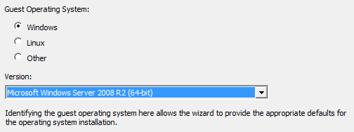

this automatically makes a selection for which vSCSI controller to use based on what drivers are available in the OS distribution.  So be sure to select the correct Guest OS to start in the right place.

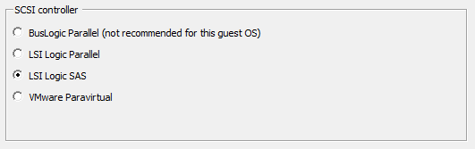

Let’s look at the options available today:

* BusLogic – this was one of the first emulated vSCSI controllers available in the VMware platform.  The earliest versions of Windows has this driver available by default which made it easy when installing that particular OS. It wasn’t however as performant as the LSI Logic driver since Windows’ driver was limited to a queue depth of 1, so often one would manually load the LSI Logic driver instead.  While still available and used occasionally (Is anyone still running Win2K?), it should be considered legacy.
* LSI Logic Parallel (formerly knows as just LSI Logic) – this was the other emulated vSCSI controller available originally in the VMware platform.  Most operating systems had a driver that supported a queue depth of 32 and it became a very common choice, if not the default.
* LSI Logic SAS – This is an evolution of the parallel driver to support a new future facing standard.  It began to grown popularity when Microsoft required its use for MCSC within Windows 2008 or newer.
* VMware Paravirtual (aka PVSCSI) – this vSCSI controller is virtualization aware and was been designed to support very high throughput with minimal processing cost and is therefore the most efficient driver. In the past, there were issues if it was used with virtual machines that didn’t do a lot of IOPS, but that was resolved in vSphere 4.1.

Are there performance differences between them?

* PVSCSI and LSI Logic Parallel/SAS are essentially the same when it comes to overall performance capability.  PVSCSI, however, is more efficient in the number of host compute cycles that are required to process the same number of IOPS. This means that if you have a very storage IO intensive virtual machine, this is the controller to choose to ensure you save as many cpu cycles as possible that can then be used by the application or host. Most modern operating systems that can drive high IO support one of these two controllers.
* Here’s a detailed [**whitepaper**](http://www.vmware.com/files/pdf/1M-iops-perf-vsphere5.pdf) that takes a closer look at PVSCSI vs LSI Logic SAS for IOPS, Latency and Cost.  While it does support that PVSCSI is more capable, keep in mind most customers are not producing 1 million IOPS so for real life the difference is negligible.

How many vSCSI adapters are supported per virtual machine?

* It’s also worth noting that you can configure a total of 4 vSCSI adapters per virtual machine.  To provide the best performance, one should also distribute virtual disk across as many vSCSI adapters as possible.  This configuration provides the capability to process more IO simultaneously and benefit from additional queues if necessary.

What about AHCI SATA?

* This is a new storage controller available with vSphere 5.5 and virtual hardware 10.  It allows you to connect a large amount of storage to a virtual machine but it wasn’t designed to be as efficient as the PVSCSI or LSI Logic controllers and therefore should not be used with performance sensitive applications.

Let’ summarize this in a chart:

**[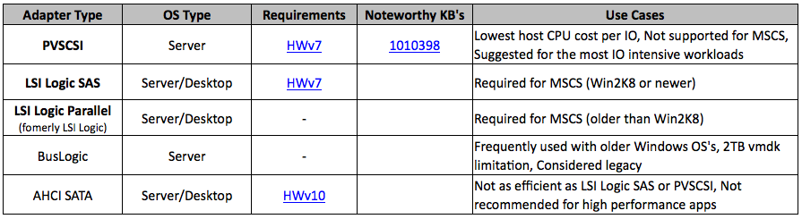](http://blogs.vmware.com/vsphere/files/2014/02/Screen-Shot-2014-02-07-at-2.25.41-PM.png)**