How to back up ESXi host configuration (2042141)

**Last Updated:**11/16/2021**Categories:**How to**Total Views:**16831 305**Language:**                         [**SUBSCRIBE**](https://kb.vmware.com/s/article/2042141)

Learn how VMware Skyline Advisor and Skyline Health Diagnostics work together to provide proactive intelligence and self-service log analysis.

* Use [**Skyline Advisor**](https://www.vmware.com/support/services/skyline.html) to avoid issues before they occur across VCF, vSphere, vSAN, NSX, vROps & Horizon. Skyline Findings are based on top KBs, VMSAs/CVEs and design best practices.
* Use [**Skyline Health Diagnostics**](https://blogs.vmware.com/vsphere/2020/09/introducing-vmware-skyline-health-diagnostic-tool.html) to root cause vSphere & vSAN logs when an issue occurs. Skyline Health Diagnostic Findings are based on top KBs and VMSA/CVEs. You can use the Skyline Health Diagnostics tool in online or offline mode.
* If you require additional help from technical support, please use [**Skyline Advisor**](https://www.vmware.com/support/services/skyline.html) to initiate a Log Assist to reduce time to upload logs. TSEs can also initiate logs to reduce effort.

Purpose

This article provides steps to back up and restore the ESXi host configuration.

Resolution

There are two conditions that need to be satisfied:  
  
i) The destination build number of the host matches the build from which the backup was taken.  
ii) The UUID of the host remains the same.

You can backup and restore the host configuration using one of these methods:

* [ESXi Command line](https://kb.vmware.com/s/article/2042141#ESXi_Command_Line)
* [vSphere CLI](https://kb.vmware.com/s/article/2042141#vSphere_CLI)
* [vSphere PowerCLI.](https://kb.vmware.com/s/article/2042141#In_vSphere_PowerCLI)

ESXi Command Line

Backing up ESXi host configuration data

1. To synchronize the configuration changed with persistent storage, run this command:

vim-cmd hostsvc/firmware/sync_config

1. To back-up the configuration data for an ESXi host, run this command:

vim-cmd hostsvc/firmware/backup_config

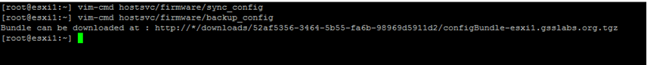

**Note:**The command will output a URL (http://*/downloads/123456/configBundle-xx.xx.xx.xx.tgz) in which a web browser may be used to download the file.

* denotes the host IP/FQDN.

1. From a web browser navigate to http://Host_FQDN/downloads/123456/configBundle-xx.xx.xx.xx.tgz

In this example the IP address of the host is 192.168.0.81

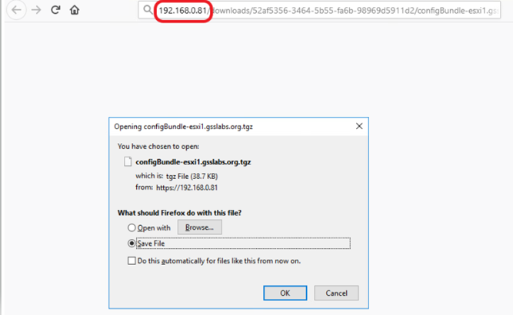

The backup file will be in the /downloads directory (default to browser or choose to download to a specific directory) as **configBundle-*HostFQDN*.tgz**

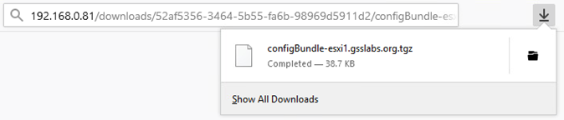

**Note:** To restore the configuration the destination ESXi host must be the same build as the ESXi host configuration data. The host build can be obtained using the command vmware -vl .

Restoring ESXi host configuration data

1. The configBundle-*HostFQDN*.tgz should be renamed as configBundle.tgz before initiating the restore command.
2. Put the host into maintenance mode by running this command:

vim-cmd hostsvc/maintenance_mode_enter

1. Copy the backup configuration file to the ESXi host or an available datastore.
2. Run this command to restore the ESXi hosts configuration:

vim-cmd hostsvc/firmware/restore_config /*backup_location*/configBundle.tgz

**Notes**:

* Add a 1 to force an override of the UUID mismatch.

For example:

vim-cmd hostsvc/firmware/restore_config 1 /tmp/configBundle.tgz

* **\**Executing this command will initiate an automatic reboot of the host after command completion.
* However, starting from vSphere 7.0 U2, the configuration could be encrypted using TPMs and in which case, the -force option will not work if the host got changed. We need the same TPM that was used on the host during backup, to restore. In other words,   
  from vSphere 7.0U2, the override will not work if the host has TPM enabled.

vSphere CLI

Backing up ESXi host configuration data

1. Run this command to backup the ESXi configuration:

vicfg-cfgbackup --server=*ESXi_host_IP_address* --username=root -s *output_file_name*

For example:

vicfg-cfgbackup --server=10.0.0.1 --username=root -s ESXi_test1_backup.tgz

**In vSphere CLI for Windows**:

1. Navigate to C:\Program Files\VMware\VMware vSphere CLI\bin
2. Run this command to backup the ESXi configuration:

vicfg-cfgbackup.pl --server=*ESXi_host_IP_address* --username=root -s *output_file_name*  
  
For example:

vicfg-cfgbackup.pl --server=10.0.0.1 --username=root -s ESXi_test1_backup.tgz

**Notes**:

* Use the --password=*root_password* option to skip the password prompt.
* A backup text file is saved in the current working directory where you run the vicfg-cfgbackup script.

Restoring ESXi host configuration data

Restoring the host configuration restores the state of the ESXi along with any vSphere standard switch networking configuration.   
  
**Note:**When restoring configuration data, the build number of the host must match the build number of the host on backup file and UUID (can be obtained using the command "esxcfg-info -u") of the host should match the UUID of the host on backup file. Use the -f option (force) to override the UUID mismatch. However, starting from vSphere 7.0 U2, the configuration could be encrypted using TPMs and in which case, the -force option will not work if the host got changed. We need the same TPM that was used on the host during backup, to restore. In other words,   
from vSphere 7.0U2, the override will not work if the host has TPM enabled.

In vSphere CLI

 To restore the configuration data for an ESXi host using the vSphere CLI:

1. Put the host that you want to restore maintenance mode.
2. Log in to a server where the vCLI is installed.
3. Run the vicfg-cfgbackup script with the -l flag to load the host configuration from the specified backup file:

**vSphere CLI**

vicfg-cfgbackup --server=*ESXi_host_IP_address* --username=root -l *backup_file*  
  
For example:  
vicfg-cfgbackup --server=10.0.0.1 --username=root -l ESXi_test1_backup.txt  
  
**vSphere CLI for Windows:**  
  
vicfg-cfgbackup.pl --server=*ESXi_host_IP_address* --username=root -l *backup_file*  
  
For example:  
vicfg-cfgbackup.pl --server=10.0.0.1 --username=root -l ESXi_test1_backup.txt  
  
**Note:**Bypass the confirmation to proceed with the -q option.  
  
To restore an ESXi host to the stock configuration settings, run the command:  
vicfg-cfgbackup --server=*ESXi_host_IP_address* --username=root -r   
  
For example:  
vicfg-cfgbackup --server=10.0.0.1 --username=root -r  
  
**Note:**ESXi host should be rebooted for the configuration changes to take effect.

In vSphere PowerCLI

Backing up ESXi host configuration data

Get-VMHostFirmware -VMHost *ESXi_host_IP_address* -BackupConfiguration -*DestinationPath* *output_directory*  
  
For ESXi 6.7, see [Reset the System Configuration](https://docs.vmware.com/en/VMware-vSphere/6.7/com.vmware.esxi.install.doc/GUID-AD450DA3-881B-4916-9231-9B6998AAC3AA.html)  
   
For example:  
   
Get-VMHostFirmware -VMHost 10.0.0.1 -BackupConfiguration -DestinationPath C:\Downloads  
   
**Note:**A backup file is saved in the directory specified with the -DestinationPath option.

Restoring ESXi host configuration data

**Note**: When restoring configuration data, the build number of the host must match the build number of the host on backup file and UUID (can be obtained using the command esxcfg-info -u) of the host should match the UUID of the host on backup file. Use the -force option to override the UUID mismatch. However, starting from vSphere 7.0 U2, the configuration could be encrypted using TPMs and in which case, the -force option will not work if the host got changed. We need the same TPM that was used on the host during backup, to restore. In other words,   
from vSphere 7.0U2, the override will not work if the host has TPM enabled.

1. Put the host into maintenance mode by running the command:

Set-VMHost -VMHost ESXi_host_IP_address -State 'Maintenance'

1. Restore the configuration from the backup bundle by running the command:

Set-VMHostFirmware -VMHost *ESXi_host_IP_address* -Restore -SourcePath backup_file -HostUser *username* -HostPassword *password*

For example:

Set-VMHostFirmware -VMHost 10.0.0.1 -Restore -SourcePath c:\bundleToRestore.tgz -HostUser root -HostPassword exampleRootPassword

Related Information

**Note**: The information about virtual machines is not stored in the config backup and the virtual machines must be re-inventoried from the datastore browser after a config backup restore. Also, bootbank information is not stored in a config backup. If needed, this must be backed up and downloaded separately in a compressed tar file.  
  
For more information, see:

* *Backing Up Configuration Information with vicfg-cfgbackup* section in the [vSphere 5.1 Command Line Documentation](http://pubs.vmware.com/vsphere-51/topic/com.vmware.vcli.examples.doc/cli_manage_hosts.4.4.html)
* *Get-VMHostFirmware* section in the [vSphere PowerCLI Reference](http://pubs.vmware.com/vsphere-51/topic/com.vmware.powercli.cmdletref.doc/Get-VMHostFirmware.html)
* *Set-VMHostFirmware* section in the [vSphere PowerCLI Reference](http://pubs.vmware.com/vsphere-51/topic/com.vmware.powercli.cmdletref.doc/Set-VMHostFirmware.html)

**Note**: if you have installed a version of vSphere later than 5.1, see the Command Line Document and PowerCLI Reference for that version in the VMware Documentation Library.  
  
**PowerCLI Notes**:

* Remember that the 64 bit version of PowerCLI is installed in C:\Program Files, and the 32 bit version is in C:\Program Files (x86).
* You must always run PowerCLI as Administrator.

https://kb.vmware.com/s/article/2042141#ESXi_Command_Line